Database Development and Class Registration
Jessica Jennings
University of Arizona Global Campus
CST499: Capstone for Computer Software Technology
Charmelia Butler
October 5, 2026

Database Development and Class Registration
Introduction
The development phase of a software project transforms documented requirements and design models into a functioning system. For the online class registration project, Week 3 established the core web application environment, including the MySQL database, PHP backend processing, and front-end pages used for account registration and login. Instructor feedback indicated that the database was well designed and organized, the backend and front-end were integrated effectively, and the registration process demonstrated appropriate validation, data processing, and user feedback. Because no major corrective issues were identified, the Week 4 implementation builds directly on that foundation by completing the database structures and class-registration functions. Software implementation should preserve traceability to requirements while maintaining data integrity, usability, and maintainability throughout development (Tsui et al., 2018). The purpose of this paper is to describe the continued implementation of the course enrollment system, including database table development, database connectivity, course registration and schedule-management functions, implementation evidence, and lessons learned during development.
Revision of Week 3 Implementation
The Week 3 work established a stable baseline for continued development. Professor Butler’s feedback stated that the MySQL database was well designed and organized, the backend and front-end integration worked well, and the registration process demonstrated effective validation, data processing, and user feedback. Therefore, the Week 4 work focused on extending verified functionality instead of redesigning successful components. This incremental approach preserves working features while adding new capabilities in a controlled manner (Tsui et al., 2018).
The existing PHP pages were retained and the project was expanded with pages for available courses, enrollment processing, the student schedule, and course deletion. Database interactions continued to use server-side PHP so that user actions could be validated before MySQL records were changed. This maintained the same basic application flow established in Week 3 while expanding the system to satisfy the remaining registration requirements.
MySQL Database and Table Development
The MySQL database was expanded with a courses table and an enrollments table. The courses table stores a course identifier, course code, course name, semester, and maximum enrollment. Five Fall courses were added for implementation testing. The enrollments table stores an enrollment identifier, the internal user identifier, the selected course identifier, and the enrollment timestamp. A unique constraint on the user and course combination prevents duplicate enrollment records. Relational database structures such as keys and related identifiers help preserve consistency and reduce unnecessary duplication (Elmasri & Navathe, 2016).
The database was inspected in phpMyAdmin before and after key operations. Before the first course registration, the enrollments table contained zero rows. After CST499 was selected through the web application, the table contained a new record linking user 1 to course 5. A second course, CST310, was subsequently added, creating another enrollment record. These database changes verified that the front-end actions were being processed successfully by PHP and persisted in MySQL.
Class Registration and Schedule Management
The available-courses page queries the courses table and displays course code, course name, semester, maximum enrollment, and an Enroll button. Selecting Enroll submits the course identifier to the enrollment-processing page. Before inserting a record, the PHP logic checks whether the student is already registered for that course. If a matching record exists, the system displays a clear duplicate-registration message rather than creating a second enrollment. Server-side validation is important because application data should remain protected even when client-side controls are bypassed (Sommerville, 2016).
The My Class Schedule page joins the enrollments and courses tables so the student sees meaningful course information instead of only numeric identifiers. The implementation successfully displayed CST499 and then CST310 after another course was added. The Drop Course function uses the selected enrollment identifier and the current user identifier to delete only the intended enrollment record. After CST310 was removed, the schedule and the database both reflected the change while CST499 remained registered.
Implementation Evidence and Testing
Testing was performed incrementally so that each operation could be verified at both the user-interface and database levels. The available-courses page confirmed successful retrieval of course data. Course registration produced a success message and a corresponding MySQL record. Attempting to register for an already selected course produced the message that the student was already registered, demonstrating duplicate-enrollment validation. The schedule page confirmed retrieval of registered courses, while the deletion test demonstrated that a selected enrollment could be removed without affecting the remaining course.
The before-and-after database screenshots provide particularly strong evidence because they verify the persistent state of the application rather than relying only on browser messages. The enrollment table changed from zero records to a CST499 registration, later contained both CST499 and CST310, and returned to one record after CST310 was dropped. The accompanying PHP screenshots document the SELECT, INSERT, JOIN, parameter-binding, and DELETE logic used to implement these operations. Testing observable behavior together with the underlying data state provides stronger evidence of implementation correctness (Tsui et al., 2018).
Implementation Experience
The implementation phase demonstrated how requirements, design, coding, database development, and testing work together. Requirements from Week 1 defined the required functions, while the design work from Week 2 provided a structure for the system. Week 3 established registration, login, database connectivity, validation, and user feedback. Week 4 extended those components into a more complete course-registration workflow.
A key practical lesson was the value of testing one function at a time. Verifying the empty enrollment table before registration, confirming each insert, and then checking the table again after deletion made it easier to determine whether the browser interface and backend data were synchronized. Prepared statements and parameter binding also provided a structured way to pass application values into SQL operations. Overall, the implementation process reinforced the importance of organized code, clear database relationships, validation, and direct verification of database changes.
Conclusion
The continued development of the online class registration system completed the major database and schedule-management functions required for the project. Building on the successful Week 3 implementation, the database was expanded to represent courses and student enrollments, and PHP pages were created to display available courses, register students, list registered courses, prevent duplicate enrollment, add additional courses, and delete a selected course. Before-and-after database verification demonstrated that the user-interface operations were reflected correctly in persistent MySQL data. The completed implementation provides a functional foundation for the capstone system while demonstrating the connection among software requirements, design, implementation, database development, validation, and testing.

References
Elmasri, R., & Navathe, S. B. (2016). Fundamentals of database systems (7th ed.). Pearson.
Sommerville, I. (2016). Software engineering (10th ed.). Pearson.
Tsui, F., Karam, O., & Bernal, B. (2018). Essentials of software engineering (4th ed.). Jones & Bartlett Learning.

Appendix A
Implementation Screenshots
The following figures document the database structures, application behavior, before-and-after database states, validation, and PHP logic used to implement the class registration system.
Figure 1
Courses Table in MySQL
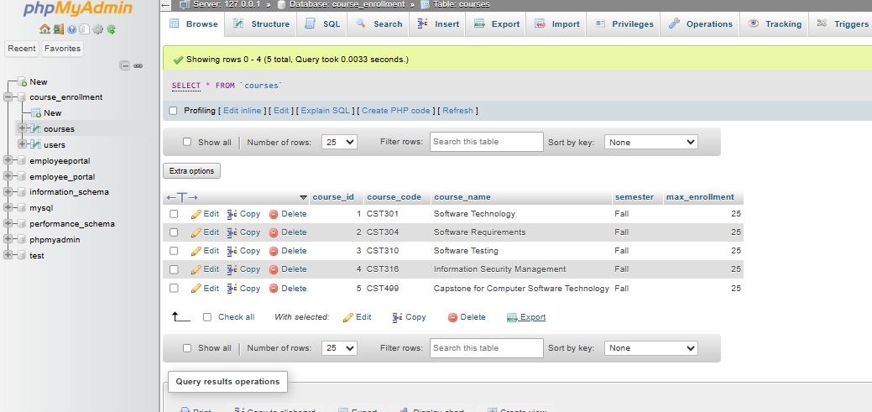
Note. The courses table contains five Fall courses and their maximum enrollment values.

Figure 2
Enrollment Table Before Registration
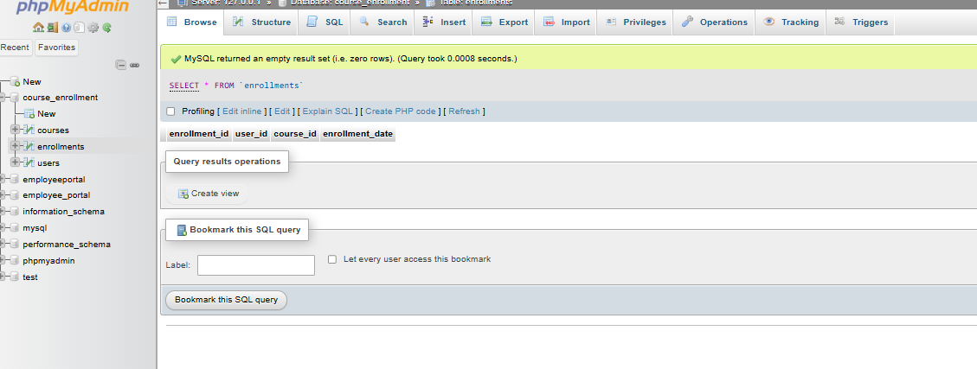
Note. The enrollments table contains zero rows before the first course is registered.

Figure 3
Available Courses Page
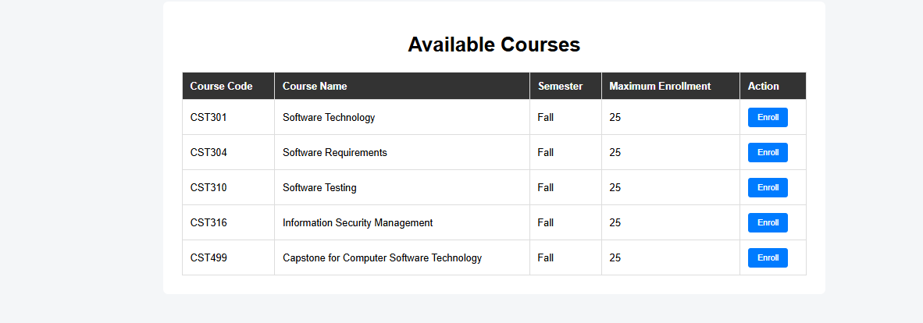
Note. The PHP page retrieves and displays the five courses stored in MySQL.

Figure 4
Successful Course Registration

Note. The application confirms that the selected course was registered successfully.

Figure 5
Enrollment Table After Registration
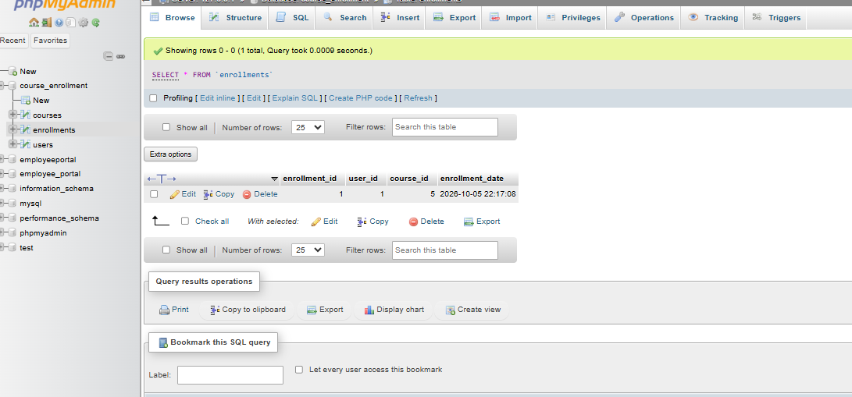
Note. MySQL shows the new enrollment linking user 1 to course 5 (CST499).

Figure 6
Student Class Schedule
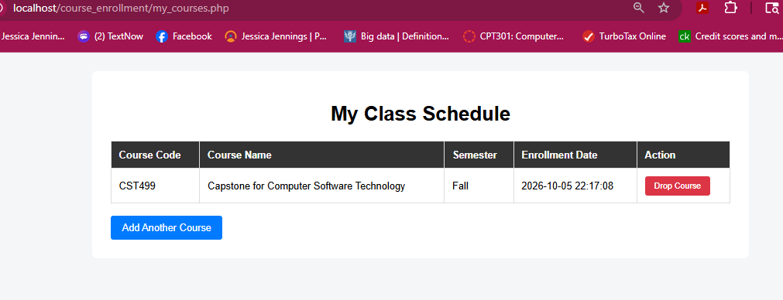
Note. The My Class Schedule page displays the registered CST499 course.

Figure 7
Schedule With Multiple Courses
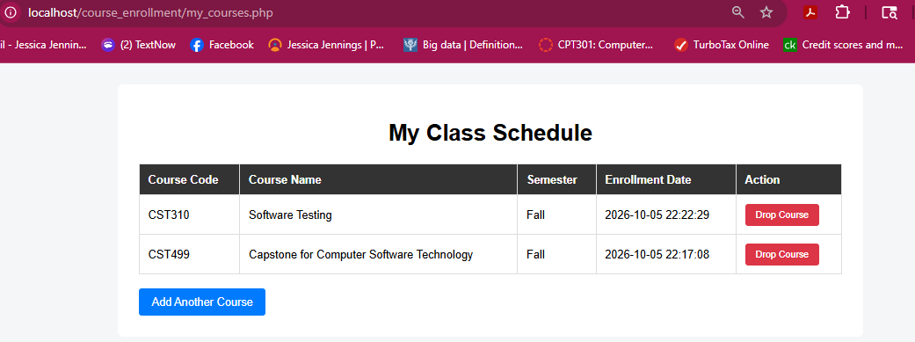
Note. The schedule shows CST310 and CST499 after an additional course is added.

Figure 8
Duplicate Enrollment Validation
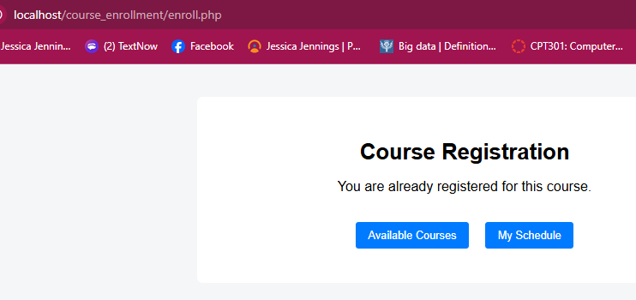
Note. The application prevents a duplicate registration and provides user feedback.

Figure 9
Enrollment Table Before Course Deletion
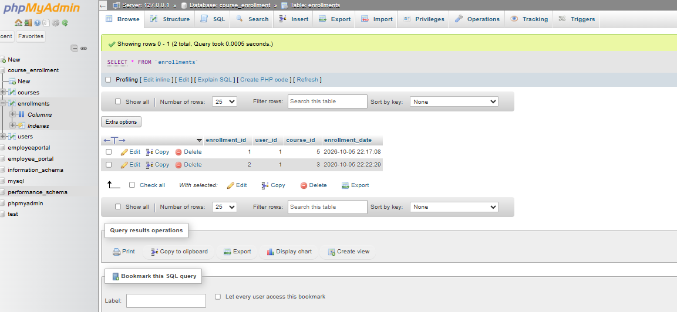
Note. The enrollments table contains course IDs 5 and 3 before CST310 is dropped.

Figure 10
Successful Course Deletion
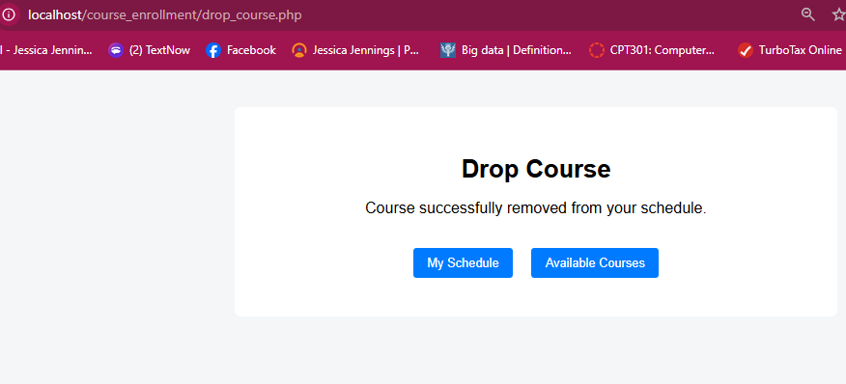
Note. The application confirms that the selected course was removed from the schedule.

Figure 11
Enrollment Table After Course Deletion
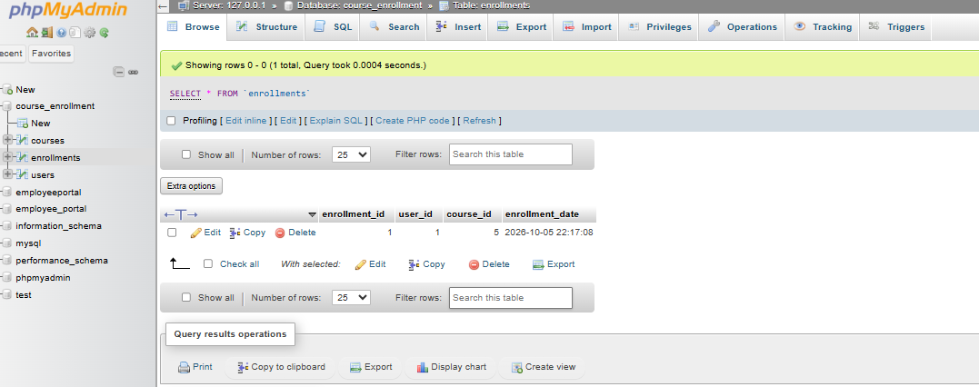
Note. Only course ID 5 remains after CST310 is removed.

Figure 12
PHP Course Registration Logic
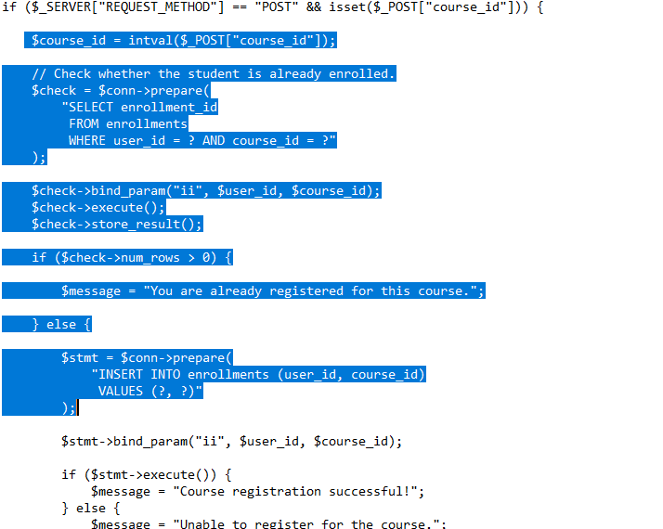
Note. Prepared statements check for duplicate enrollment and insert a new enrollment record.

Figure 13
PHP Registered-Course Query
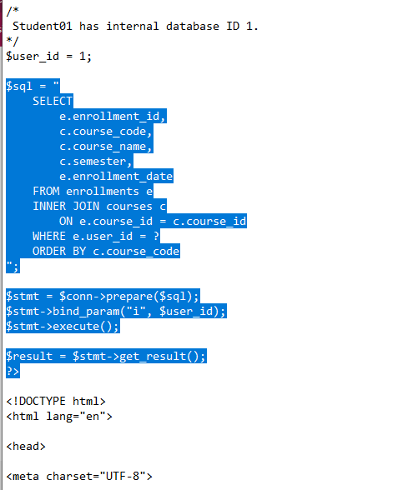
Note. The schedule query joins enrollments and courses and filters results by user ID.

Figure 14
PHP Course Deletion Logic
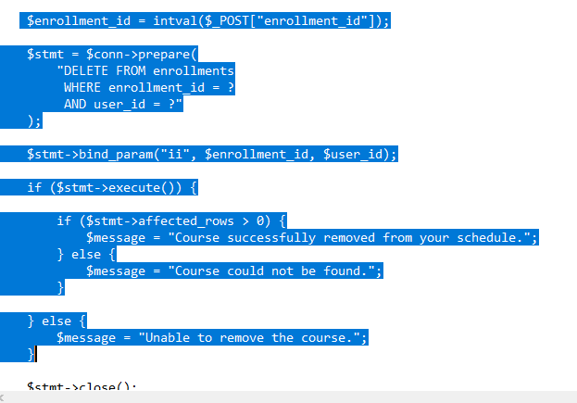
Note. The deletion logic removes the selected enrollment for the specified user.

Figure 15
PHP Available-Course Query
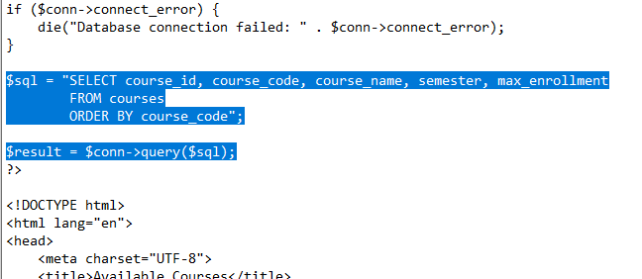
Note. The available-courses page selects course information from the courses table.

Figure 16
PHP Enrollment Form Logic
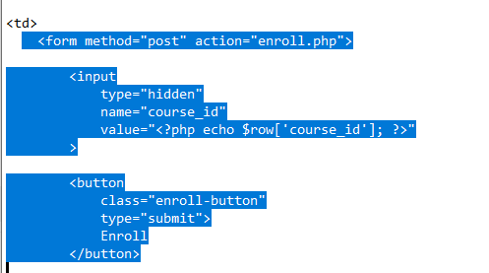
Note. The form submits the selected course ID to enroll.php when the Enroll button is selected.

